  

**MATHEMATICS**

**Specialist Units 3 & 4**

**Test 3 – Vectors**

**Semester 1 2019**

# 

**Section One – Calculator Free**

Time allowed for this section

Working time for this section: 25 minutes

Marks available: 27 marks

## Material required/recommended for this section

##### To be provided by the supervisor

This Question/Answer booklet

Formula sheet

##### To be provided by the candidate

Standard items: pens, pencils, pencil sharpener, eraser, correction fluid, ruler, highlighters

Special items: Nil

## Important note to candidates

No other items may be used in this section of the examination. It is **your** responsibility to ensure that you do not have any unauthorised notes or other items of a non-personal nature in the examination room. If you have any unauthorised material with you, hand it to the supervisor **before** reading any further.

1. (5 marks)  
   Determine the value of *a* given the three planes below meet along a common line:

$x+3y+3z=a-1$

$r.〈2, -1, 1〉=7$

$3x-5y+az=16$

1. (11 marks: 3, 2, 1, 2, 1, 2)

The motion of a particle at time $t$ hours is given by:

$r\left(t\right)=\left(10cos⁡\left(\frac{π}{6}t\right)\right)i+\left(20\sin\left(\frac{π}{6}t\right)\right)j km$, for $t≥0$

1. Find the Cartesian equation of the path
2. On the axes below, sketch the path of the particle. Indicate clearly the direction of motion of the particle.

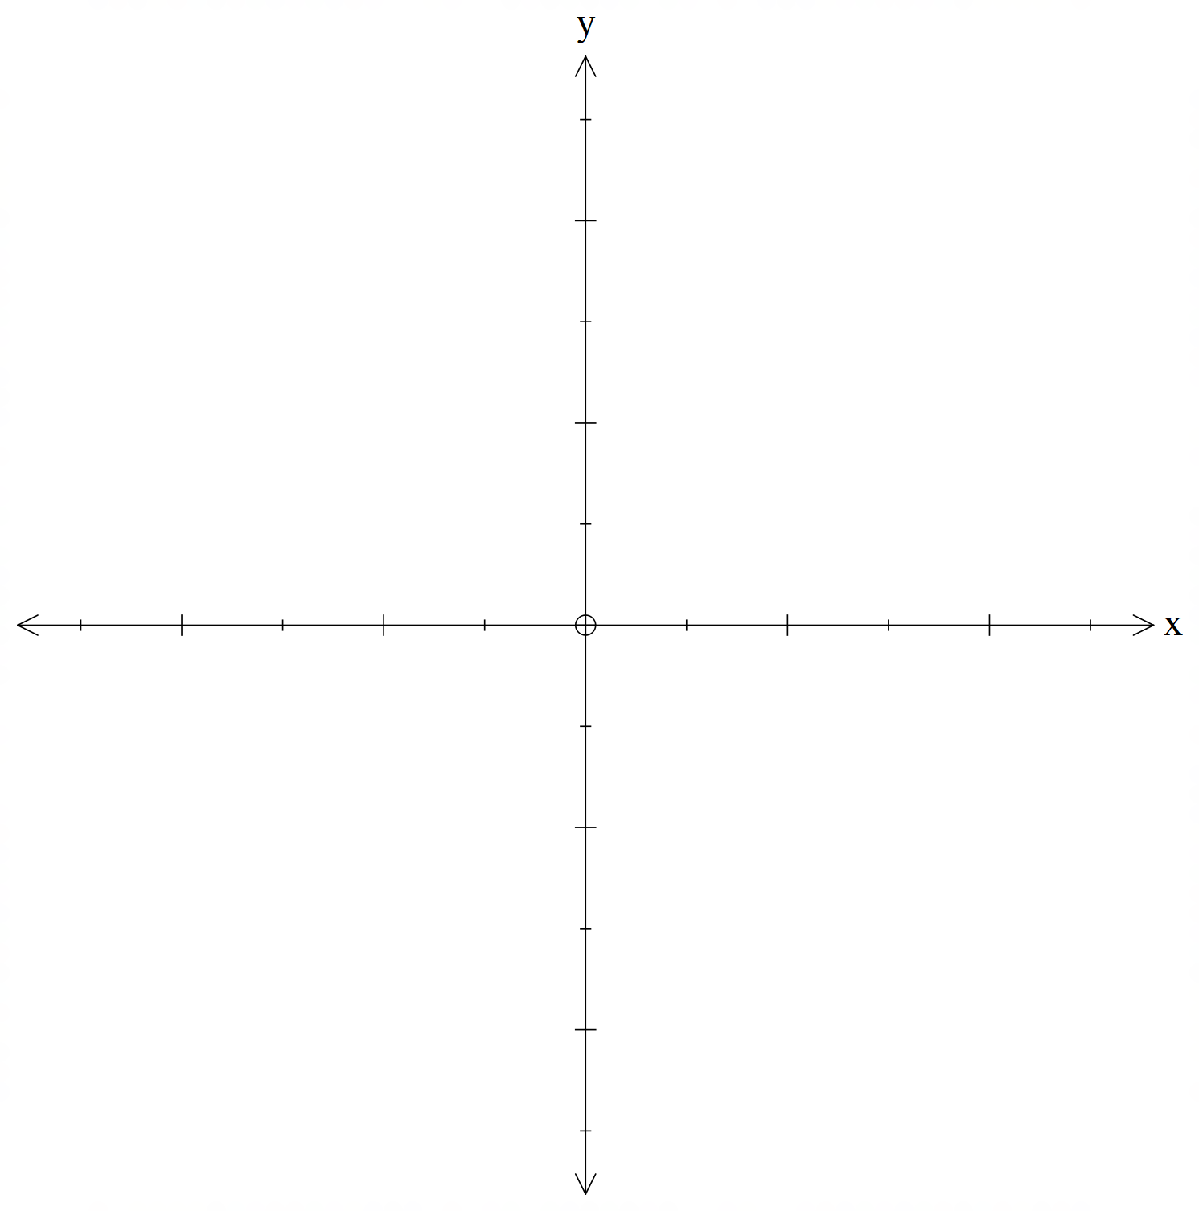

1. How long does it take the particle to return to its initial position?
2. Determine at what times the particle is moving perpendicular to its displacement vector.
3. Find $v(t)$, the velocity vector of the particle at any time $t$ hours.
4. Prove the acceleration of the particle is parallel to the path of the particle.
5. (11 marks: 2, 4, 5)

VABCD is a square based pyramid.

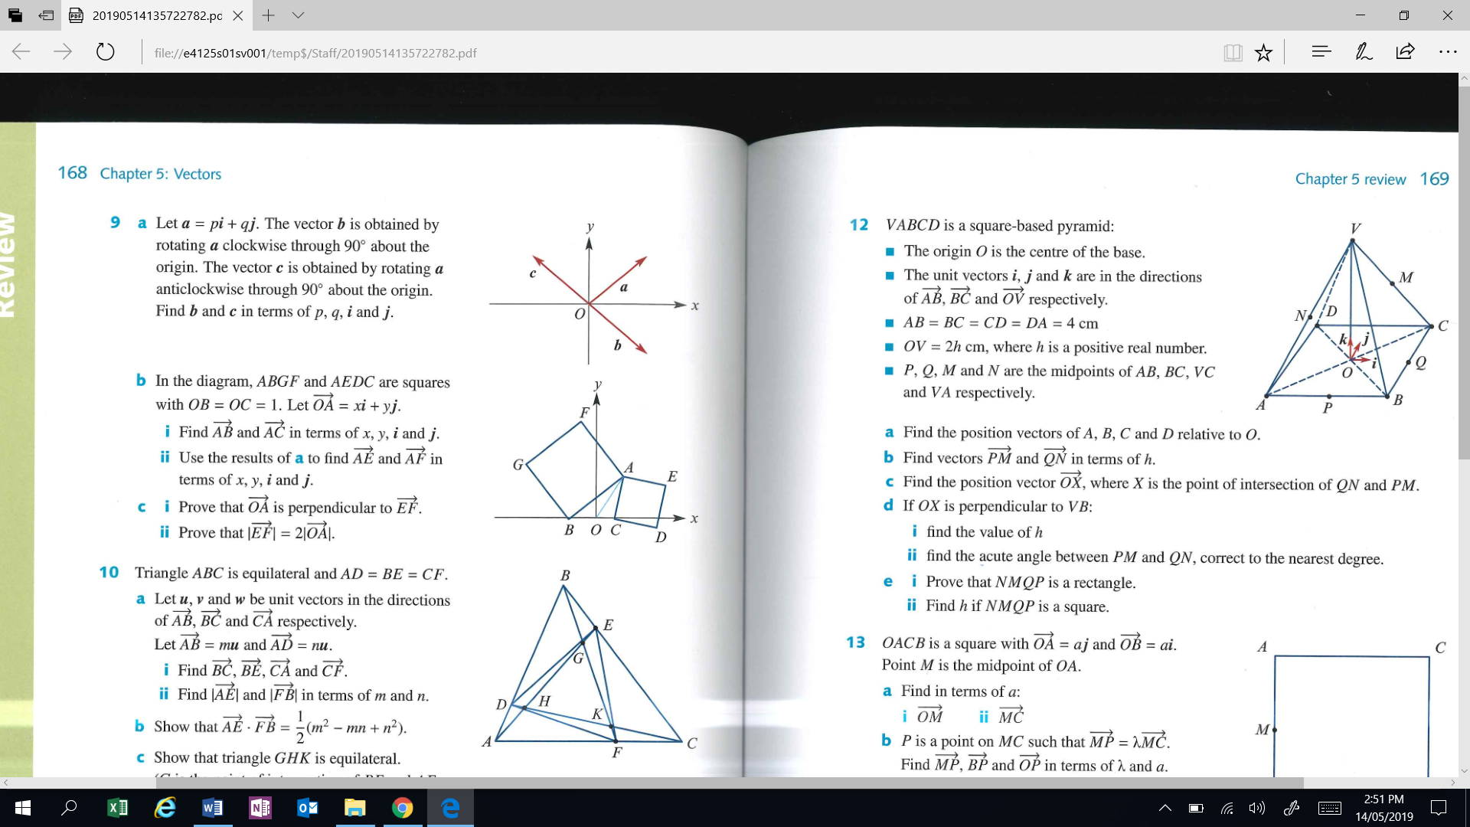

* The origin *O* is the centre of the base.
* The unit vectors **i**, **j** and **k** are in the directions of $\vec{AB}, \vec{ BC}$ and $\vec{OV}$ respectively.
* *AB* = *BC* = *CD* = *DA* = 4cm
* *OV* = 2h cm, where h is a positive real number
* *P, Q, M* and *N* are the midpoints of *AB, BC, VC* and *VA* respectively.
* $\vec{PM}=〈1, 3, h〉$ and $\vec{QN}=〈-3, -1, h〉$

1. Determine the position vectors of *P* and *Q*
2. Determine the position vector $\vec{OX}$, where *X* is the point of intersection of *QN* and *PM*. Hint: Determine the equations of the lines containing vectors $\vec{PM}$ and $\vec{QN}$
3. Given *OX* is perpendicular to *VB*, determine the value of *h*.

**End of Section One**

**This page has intentionally been left blank**

You may use this space to extend or re-attempt an answer to a question or questions and should you do so then number the question(s) attempted and cross out any previous unwanted working.